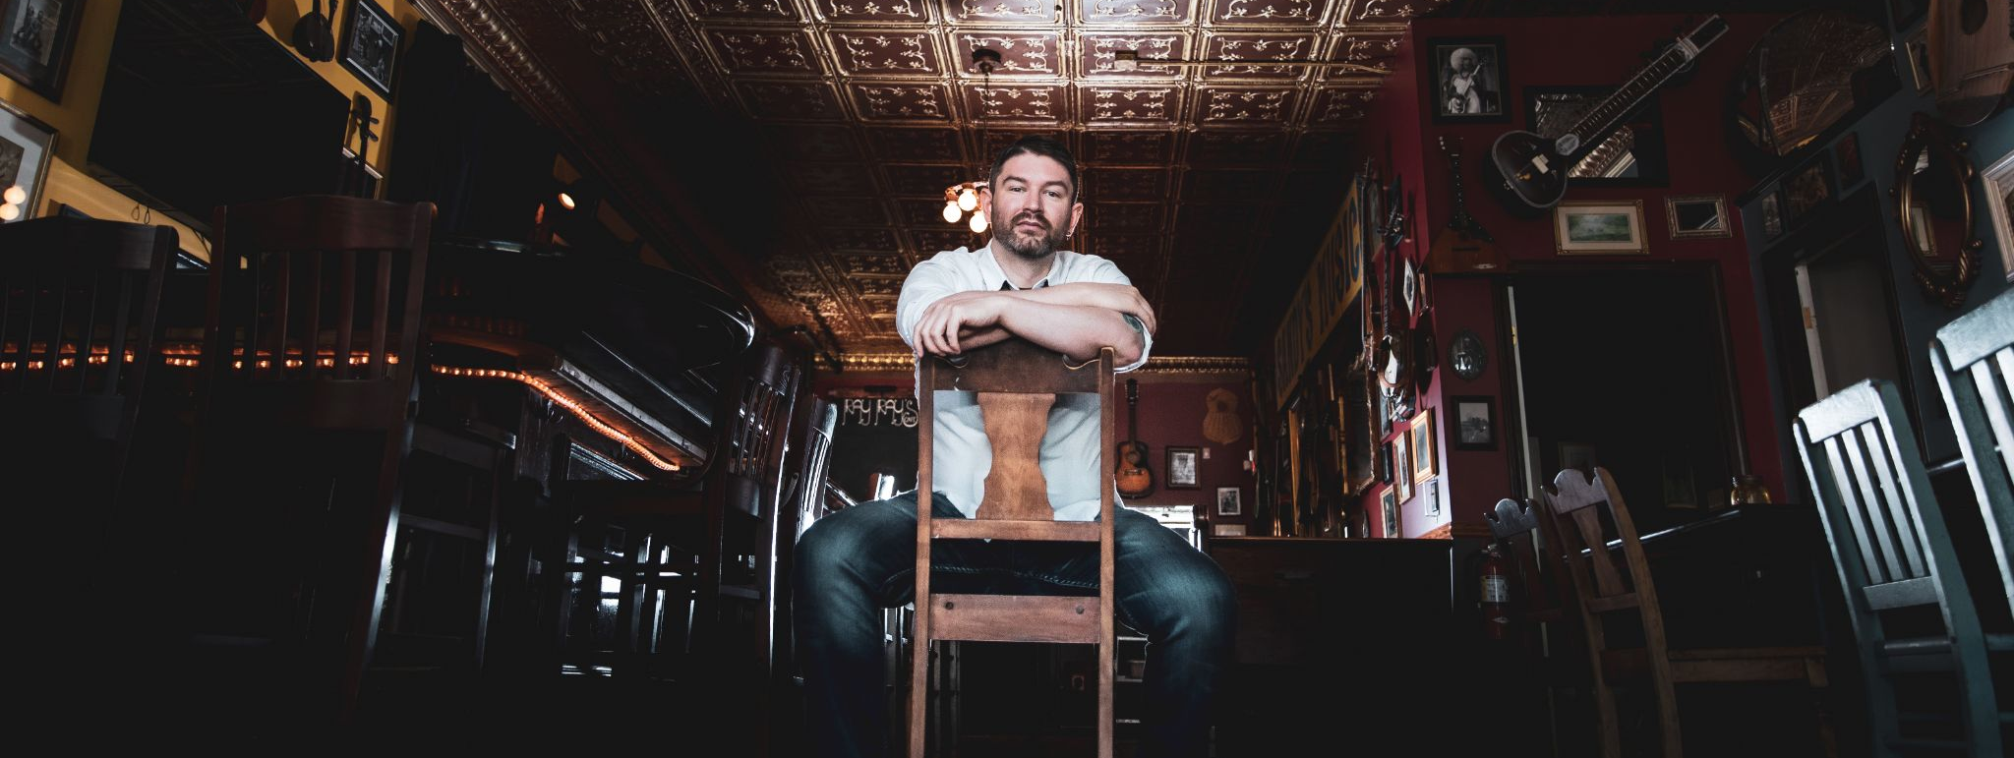

DC WOLVES RELEASES NEW EP, NIGHTHAWK

HARTFORD 1 April 2021 – Under the cover of night, the world is redefined, only to be known and discovered by those brave enough to step into it. For songwriter and multi-instrumentalist, Dan Cahill—DC Wolves—this unknown serves as a foundational catalyst into new music that is both singular and inclusive, mysterious and candid, exhilarating and grounded, cohesive and diverse. And it’s in the space between these contrasts that DC Wolves finds its lifeblood. With the vigor of a new challenge and the pride of a personal showcase, this rock connoisseur is back with his latest EP, Nighthawk.

“With Nighthawk, I was looking to start exploring different song structures and moods” says Cahill. “I always want to challenge myself to try new things, so that every release is a surprise to listeners.”

Since the band’s start in 2016, Cahill has explored every corner of rock music that he can. The Nighthawk EP is DC Wolves’ second studio album, following his full-length debut, You’ve Been Careless. Cahill’s latest releases showcases the full span of his feel-driven songwriting chops with a non-traditional approach to traditional rock styles. “For this release, I took influence from major artists like Queens of the Stone Age and Mumford & Sons, as well as lesser known artists such as Cave In, Death From Above 1979 and Minus the Bear.”

With a personal test to tackle new musical feats and push boundaries in ways he never has before, the Nighthawk EP is both a monument in Cahill’s career and a cornerstone that paves the way for another full-length album later this year. Nighthawk will be available everywhere Friday, April 30. Learn more and stay in touch at dcwolves.com.

# # #
About DC Wolves:
On the fringes of a main road in a small Connecticut town, self-built songwriter and multi-instrumentalist, Dan Cahill spent endless hours hunting down every note he could play and every sound he could imagine. As years of playing in metal, rock, and shoegaze bands blended into routine, Cahill grew an appetite for both creative autonomy and synergistic collaboration. In 2016, he ventured out into the wilderness in search of a sound he could call his own, and a pack of original minds to bring it to life. It wasn’t until the next year that his music took shape and his solo project, DC Wolves rose to the surface.

